# Homework 2

520021911347 郑航

练习3

结果截图：

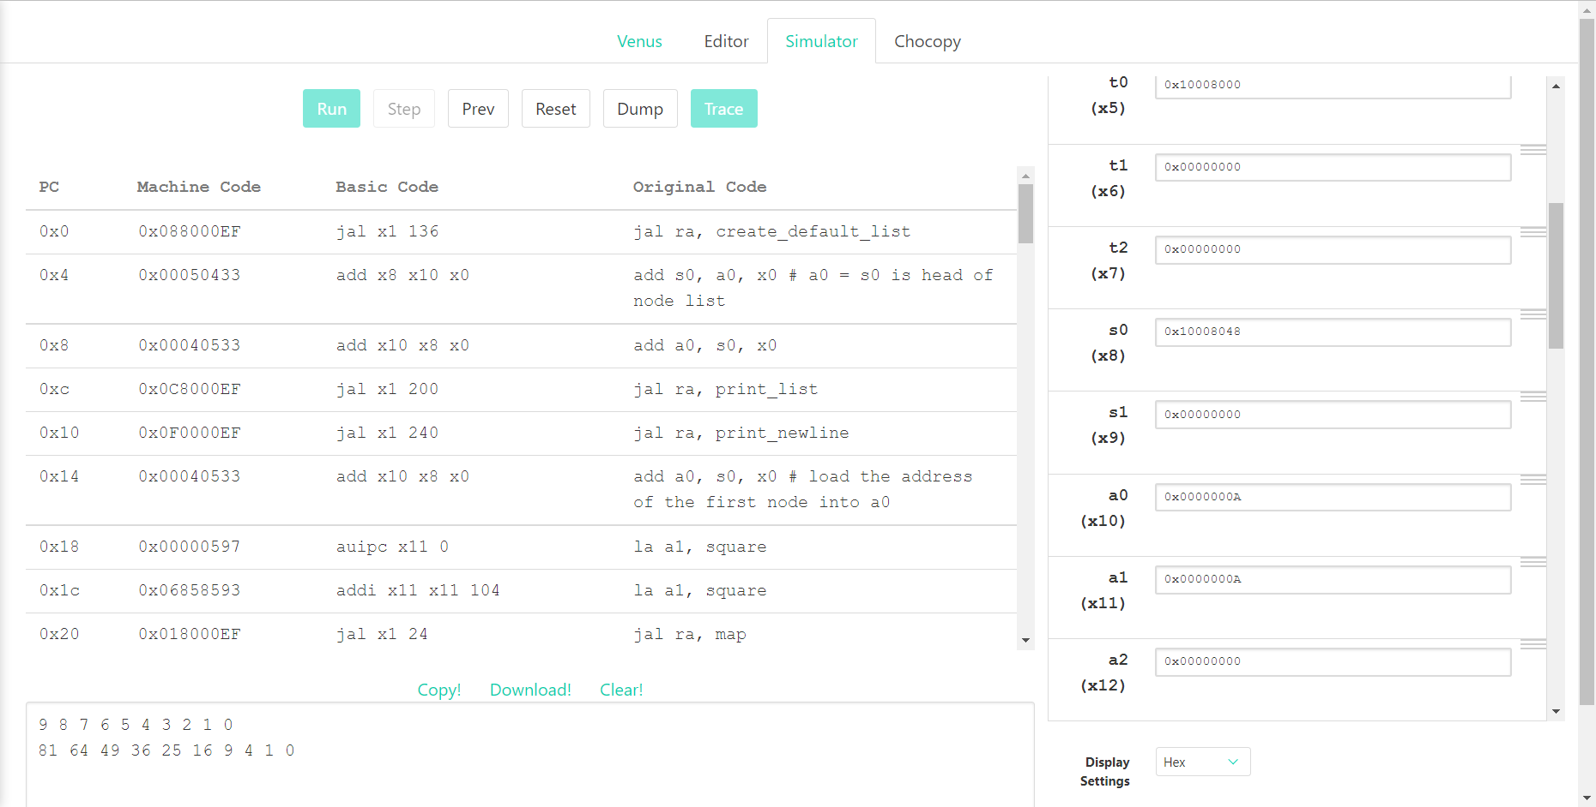

代码：

|  |
| --- |
| .globl map  .text  main:  jal ra, create_default_list  add s0, a0, x0 # a0 = s0 is head of node list  #print the list  add a0, s0, x0  jal ra, print_list  # print a newline  jal ra, print_newline  # load your args  add a0, s0, x0 # load the address of the first node into a0  # load the address of the function in question into a1 (check out la on the green sheet)  ### YOUR CODE HERE ###  la a1, square  # issue the call to map  jal ra, map  # print the list  add a0, s0, x0  jal ra, print_list  # print another newline  jal ra, print_newline  addi a0, x0, 10  ecall #Terminate the program  map:  # Prologue: Make space on the stack and back-up registers  ### YOUR CODE HERE ###  addi sp sp -12  sw s0 0(sp)  sw s1 4(sp)  sw ra 8(sp)    beq a0, x0, done # If we were given a null pointer (address 0), we're done.  add s0, a0, x0 # Save address of this node in s0  add s1, a1, x0 # Save address of function in s1  # Remember that each node is 8 bytes long: 4 for the value followed by 4 for the pointer to next.  # What does this tell you about how you access the value and how you access the pointer to next?  # load the value of the current node into a0  # THINK: why a0?  ### YOUR CODE HERE ###  lw a0 0(s0)  # Call the function in question on that value. DO NOT use a label (be prepared to answer why).  # What function? Recall the parameters of "map"  ### YOUR CODE HERE ###  jalr ra a1 0  # store the returned value back into the node  # Where can you assume the returned value is?  ### YOUR CODE HERE ###  sw a0 0(s0)  # Load the address of the next node into a0  # The Address of the next node is an attribute of the current node.  # Think about how structs are organized in memory.  ### YOUR CODE HERE ###  lw a0 4(s0)  # Put the address of the function back into a1 to prepare for the recursion  # THINK: why a1? What about a0?  ### YOUR CODE HERE ###  add a1 s1 x0  # recurse  ### YOUR CODE HERE ###  jal ra, map  done:  # Epilogue: Restore register values and free space from the stack  ### YOUR CODE HERE ###  lw s0 0(sp)  lw s1 4(sp)  lw ra 8(sp)  addi sp sp 12  jr ra # Return to caller  square:  mul a0 ,a0, a0  jr ra  create_default_list:  addi sp, sp, -12  sw ra, 0(sp)  sw s0, 4(sp)  sw s1, 8(sp)  li s0, 0 # pointer to the last node we handled  li s1, 0 # number of nodes handled  loop: #do...  li a0, 8  jal ra, malloc # get memory for the next node  sw s1, 0(a0) # node->value = i  sw s0, 4(a0) # node->next = last  add s0, a0, x0 # last = node  addi s1, s1, 1 # i++  addi t0, x0, 10  bne s1, t0, loop # ... while i!= 10  lw ra, 0(sp)  lw s0, 4(sp)  lw s1, 8(sp)  addi sp, sp, 12  jr ra  print_list:  bne a0, x0, printMeAndRecurse  jr ra # nothing to print  printMeAndRecurse:  add t0, a0, x0 # t0 gets current node address  lw a1, 0(t0) # a1 gets value in current node  addi a0, x0, 1 # prepare for print integer ecall  ecall  addi a1, x0, ' ' # a0 gets address of string containing space  addi a0, x0, 11 # prepare for print string syscall  ecall  lw a0, 4(t0) # a0 gets address of next node  jal x0, print_list # recurse. We don't have to use jal because we already have where we want to return to in ra  print_newline:  addi a1, x0, '\n' # Load in ascii code for newline  addi a0, x0, 11  ecall  jr ra  malloc:  addi a1, a0, 0  addi a0, x0 9  ecall  jr ra |

练习4

结果截图：

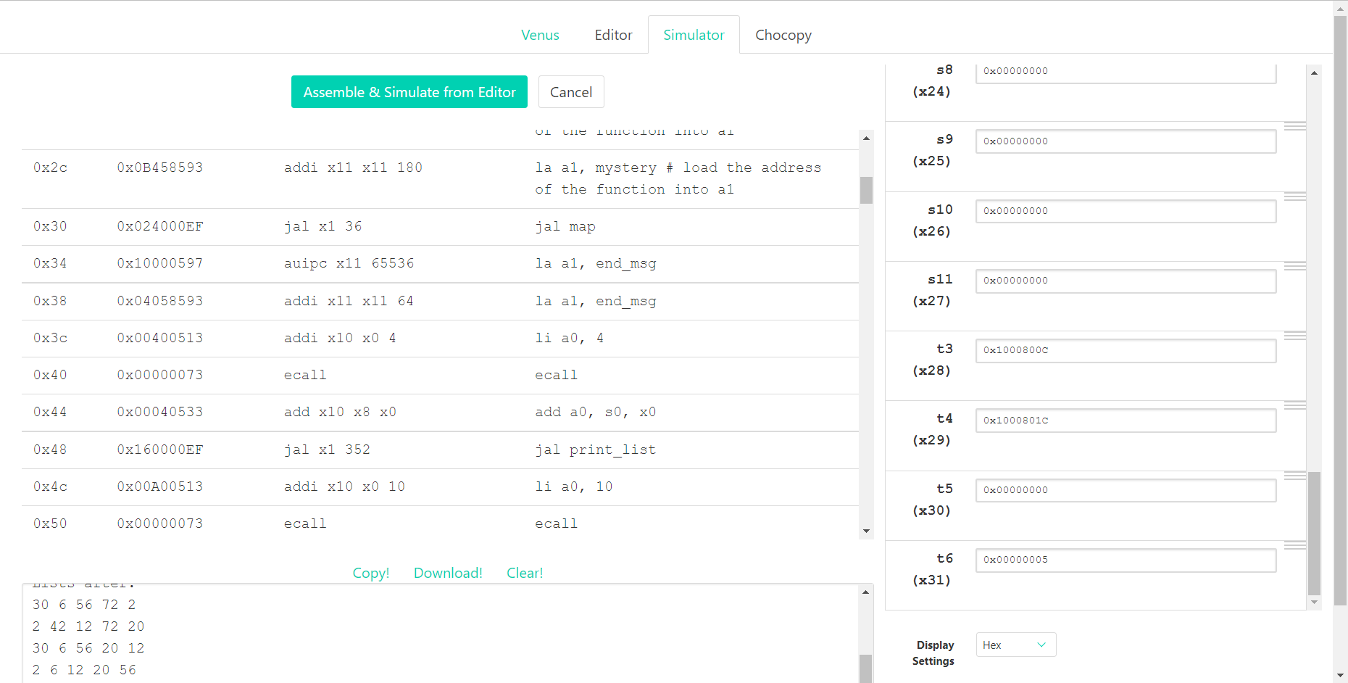

代码：

|  |
| --- |
| .globl map  .data  arrays: .word 5, 6, 7, 8, 9  .word 1, 2, 3, 4, 7  .word 5, 2, 7, 4, 3  .word 1, 6, 3, 8, 4  .word 5, 2, 7, 8, 1  start_msg: .asciiz "Lists before: \n"  end_msg: .asciiz "Lists after: \n"  .text  main:  jal create_default_list  mv s0, a0 # v0 = s0 is head of node list  #print "lists before: "  la a1, start_msg  li a0, 4  ecall  #print the list  add a0, s0, x0  jal print_list  # print a newline  jal print_newline  # issue the map call  add a0, s0, x0 # load the address of the first node into a0  la a1, mystery # load the address of the function into a1  jal map  # print "lists after: "  la a1, end_msg  li a0, 4  ecall  # print the list  add a0, s0, x0  jal print_list  li a0, 10  ecall  map:  addi sp, sp, -12  sw ra, 0(sp)  sw s1, 4(sp)  sw s0, 8(sp)  beq a0, x0, done # if we were given a null pointer, we're done.  add s0, a0, x0 # save address of this node in s0  add s1, a1, x0 # save address of function in s1  add t0, x0, x0 # t0 is a counter  # remember that each node is 12 bytes long:  # - 4 for the array pointer  # - 4 for the size of the array  # - 4 more for the pointer to the next node  # also keep in mind that we should not make ANY assumption on which registers  # are modified by the callees, even when we know the content inside the functions  # we call. this is to enforce the abstraction barrier of calling convention.  mapLoop:  lw t1, 0(s0) # load the address of the array of current node into t1  lw t2, 4(s0) # load the size of the node's array into t2  slli t3, t0, 2  add t1, t1, t3 # offset the array address by the count  lw a0, 0(t1) # load the value at that address into a0  addi sp, sp, -4  sw t1, 0(sp)  jalr s1 # call the function on that value.  lw t1, 0(sp)  addi sp, sp, 4  sw a0, 0(t1) # store the returned value back into the array  addi t0, t0, 1 # increment the count  bne t0, t2, mapLoop # repeat if we haven't reached the array size yet    lw a0, 8(s0) # load the address of the next node into a0  add a1, s1, x0 # put the address of the function back into a1 to prepare for the recursion  jal map # recurse  done:  lw s0, 8(sp)  lw s1, 4(sp)  lw ra, 0(sp)  addi sp, sp, 12  jr ra  print_newline:  li a1, '\n'  li a0, 11  ecall  jr ra  mystery:  mul t1, a0, a0  add a0, t1, a0  jr ra  create_default_list:  addi sp, sp, -24  sw ra, 0(sp)  sw s0, 4(sp)  sw s1, 8(sp)  sw s2, 12(sp)  sw s3, 16(sp)  sw s4, 20(sp)  li s0, 0 # pointer to the last node we handled  li s1, 0 # number of nodes handled  li s2, 5 # size  la s3, arrays  loop: #do...  li a0, 12  jal malloc # get memory for the next node  mv s4, a0  li a0, 20  jal malloc # get memory for this array  sw a0, 0(s4) # node->arr = malloc  lw a0, 0(s4)  mv a1, s3  jal fillArray # copy ints over to node->arr  sw s2, 4(s4) # node->size = size (4)  sw s0, 8(s4) # node-> next = previously created node  add s0, x0, s4 # last = node  addi s1, s1, 1 # i++  addi s3, s3, 20 # s3 points at next set of ints  li t6 5  bne s1, t6, loop # ... while i!= 5  mv a0, s4  lw ra, 0(sp)  lw s0, 4(sp)  lw s1, 8(sp)  lw s2, 12(sp)  lw s3, 16(sp)  lw s4, 20(sp)  addi sp, sp, 24  jr ra  fillArray: lw t0, 0(a1) #t0 gets array element  sw t0, 0(a0) #node->arr gets array element  lw t0, 4(a1)  sw t0, 4(a0)  lw t0, 8(a1)  sw t0, 8(a0)  lw t0, 12(a1)  sw t0, 12(a0)  lw t0, 16(a1)  sw t0, 16(a0)  jr ra  print_list:  bne a0, x0, printMeAndRecurse  jr ra # nothing to print  printMeAndRecurse:  mv t0, a0 # t0 gets address of current node  lw t3, 0(a0) # t3 gets array of current node  li t1, 0 # t1 is index into array  printLoop:  slli t2, t1, 2  add t4, t3, t2  lw a1, 0(t4) # a0 gets value in current node's array at index t1  li a0, 1 # preparte for print integer ecall  ecall  li a1, ' ' # a0 gets address of string containing space  li a0, 11 # prepare for print string ecall  ecall  addi t1, t1, 1  li t6 5  bne t1, t6, printLoop # ... while i!= 5  li a1, '\n'  li a0, 11  ecall  lw a0, 8(t0) # a0 gets address of next node  j print_list # recurse. We don't have to use jal because we already have where we want to return to in ra  malloc:  mv a1, a0 # Move a0 into a1 so that we can do the syscall correctly  li a0, 9  ecall  jr ra |

练习5

结果截图：

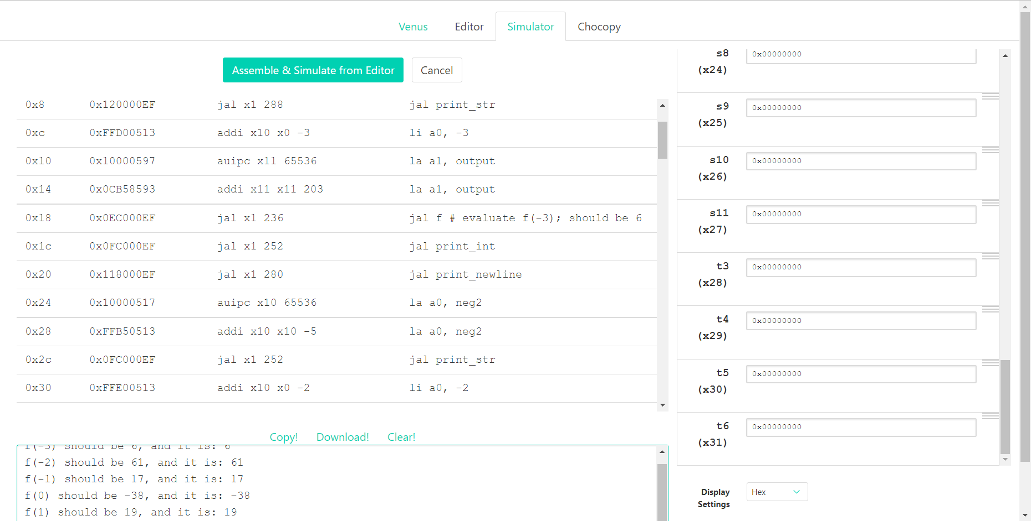

代码：

|  |
| --- |
| .globl f  .data  neg3: .asciiz "f(-3) should be 6, and it is: "  neg2: .asciiz "f(-2) should be 61, and it is: "  neg1: .asciiz "f(-1) should be 17, and it is: "  zero: .asciiz "f(0) should be -38, and it is: "  pos1: .asciiz "f(1) should be 19, and it is: "  pos2: .asciiz "f(2) should be 42, and it is: "  pos3: .asciiz "f(3) should be 5, and it is: "  output: .word 6, 61, 17, -38, 19, 42, 5  .text  main:  la a0, neg3  jal print_str  li a0, -3  la a1, output  jal f # evaluate f(-3); should be 6  jal print_int  jal print_newline  la a0, neg2  jal print_str  li a0, -2  la a1, output  jal f # evaluate f(-2); should be 61  jal print_int  jal print_newline  la a0, neg1  jal print_str  li a0, -1  la a1, output  jal f # evaluate f(-1); should be 17  jal print_int  jal print_newline  la a0, zero  jal print_str  li a0, 0  la a1, output  jal f # evaluate f(0); should be -38  jal print_int  jal print_newline  la a0, pos1  jal print_str  li a0, 1  la a1, output  jal f # evaluate f(1); should be 19  jal print_int  jal print_newline  la a0, pos2  jal print_str  li a0, 2  la a1, output  jal f # evaluate f(2); should be 42  jal print_int  jal print_newline  la a0, pos3  jal print_str  li a0, 3  la a1, output  jal f # evaluate f(3); should be 5  jal print_int  jal print_newline  li a0, 10  ecall  # f takes in two arguments:  # a0 is the value we want to evaluate f at  # a1 is the address of the "output" array (defined above).  # Think: why might having a1 be useful?  f:  # YOUR CODE GOES HERE!  addi t0 a0 3  slli t1 t0 2  add a1 a1 t1  lw a0 0(a1)  jr ra # Always remember to jr ra after your function!  print_int:  mv a1, a0  li a0, 1  ecall  jr ra  print_str:  mv a1, a0  li a0, 4  ecall  jr ra  print_newline:  li a1, '\n'  li a0, 11  ecall  jr ra |